TITLE OF THE PAPER
First A. Author⁽¹⁾, Second B. Author⁽²⁾, Third C. Author⁽³⁾
⁽¹⁾ MS, Lecturer, faculty of civil engineering, Hanoi Architectural University, Email: <dhkt@hau.edu.vn>
⁽²⁾ Degree, academic title, affiliation, second author’s email
⁽³⁾ Degree, academic title, affliation, third author’s email
Abstract: Described in this document are the formatting requirements for full papers for the scientific conference MSC 2024 celebrating the 55th anniversary of the establishment of Hanoi Architectural University. The full paper shall be written in compliance with these instructions. Please review this document to learn about the formatting of text, table captions and references. The paper should be written in Microsoft Word for convenient editing and printing. The abstract should consist of one paragraph having no more than 150 words. The abstract should present a concise statement of the scope, principal findings, and conclusions of the paper.
Keywords: (4 to 6 keywords, separated by commas) keyword 1, keyword 2, keyword 3, keyword 4.

Introduction
It is expected that authors will submit carefully written and proofread material. Papers should clearly describe the background of the subject, the author(s) contribution, including the specific argument, research methods used, results and concluding discussion on the importance of the work from both scholarly and critical perspectives in the fields of materials, structures and construction technology.
The full paper should be no more than 8 pages in length.
We look forward to receiving your submissions and welcoming you to Hanoi Capital, Vietnam.

Page size
All material on each page should fit A4 portrait, format (297x210mm), centered on the page, beginning 3 cm from the top of the page and ending with 3 cm from the bottom. The right and left margins should be 3 cm.

Text format
Please use 11-point Arial font. The line spacing is exactly at 14 pt, before spacing is 6 pt, after spacing is 0 pt, alignment is justified

Equations, figures and tables

Equations
Equations and symbols should be typed in the equation editor. Number equations consecutively with equation numbers in parentheses, as in
$σ_{\text{cr}}=σ_{\text{mu}}+σ_{R}^{'}(V_{r})^{1\text{.}1}$ (1)

Figures and tables
All graphics (photos, line art, and tables) must be embedded within the document and fit within the specified margins.
Figures and tables should be numbered consecutively and captioned as follows
Table 1: An example of tables
Column 1 | Column 2 | Column 3 | Column 4
a | b | c | d
e | f | g | h

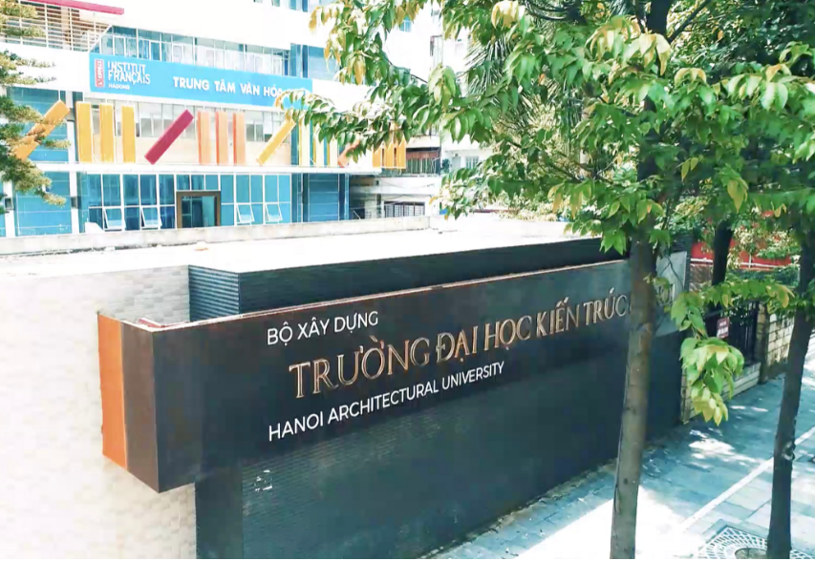
Figure 1: Hanoi Architectural University

References
1. L. Thanh and Y. Itoh. Performances of Curved Steel Bridge Railing Subjected to Truck Collision. Journal of Engineering Structures, Vol. 54, 33-46, 2013.
2. Y. Itoh, M. Mori and C. Liu. Numerical Analyses on High Capacity Steel Guard Fences Subjected to Vehicle Collision Impact. 4th International Conference on Steel and Aluminium Structures, Espoo, Finland, 53-60, 1999.
3. Japan Road Association. The Specifications of Railing Design. Maruzen Press, Tokyo, Japan, 2004.

